Student’s Name
Professor Bailie
English 2089
25 November 2017
Assignment Two
John Tyler Morgan’s essay The Race Question in the United States is haunting me like a ghost. Specifically, as a classic spectral figure garbed in white with dark, soulless holes for eyes. Or perhaps I’m just recalling the Klan uniforms displayed so proudly and prominently in D.W. Griffith’s 1915 film The Birth of a Nation. It’s not unreasonable for the two to amalgamate in my mind, as they cover so much of the same ground within their respective mediums. Both The Race Question and Birth of a Nation make passionate (astoundingly racist) cases regarding the Antebellum South and the Civil War, as well as the Reconstruction Period and the burgeoning notion of Civil Rights. Morgan also touches on the Post-Reconstruction Era, but that’s where the parallels fade away. The Birth of a Nation concludes its story before reaching the end of Reconstruction, opting instead to leave the audience with a heavy handed, overtly religious pair of visions regarding potential futures, each related to the effectiveness of the Klan’s voter suppression efforts. Conversely, The Race Question was specifically written with the goal of persuading Morgan’s audience to join him in opposition of the Blair and Force Bills during the Post-Reconstruction Period (1890).
Griffith’s film does not argue outright for such a specific claim. While it certainly intends to persuade its audience, it’s contents do not correspond to something so specific as a Congressional motion like The Race Question does. The Birth of a Nation argued more generally that its audience should be resistant to attempts at reducing or eliminating voter suppression when aimed at African Americans.
In a broader sense, the film is also an ardent upholder of the fatuous tenets of biological determinism. Something which Morgan transparently subscribes to as well. Morgan’s easily discernable subscription to these ideals brings attention to a strange aspect of his essay, which is structured and worded as an appeal to logic, but does not hold up to logical analysis of its arguments and examples. His essay was effective instead as an appeal to its audience's emotions. I will not pretend to know whether this was some masterful manipulation on Morgan’s part -- disguising an emotional appeal as a logical set of claims, examples, and conclusions -- which just happens to be riddled with assumptions and contradictions, or if he sincerely believed he was making a strong logical case, but was blinded to its fallacies by his own convictions (and just happened instead to strike a strong emotional response from his audience). But in the context of this comparison, that issue is irrelevant, as the result is the same. Between The Race Question in the United States and The Birth of a Nation, Morgan makes the weaker emotional appeal because he presents it as a logical one, whereas Griffith’s film makes direct use of highly-charged visuals to maximize its emotional impact upon the audience.
I wish to reiterate before I continue that both of these works are astoundingly racist, and I absolutely do not agree with their claims. It is simply my given task to analyze and compare them as rhetorical appeals within the context of their effectiveness towards the film’s 1915 audience. I already detailed why I believe that Morgan’s Race Question essay likely found more traction as an emotional appeal, rather than the logical one it pretends to be. The issues with Race Question as a logical argument are an essay in themselves, one that I’ve already written. What I did not spend much time on in my prior essay was Morgan’s “central and vital point” (Morgan 73) as he puts it, of interracial marriage. Needless to say, he stood fervently against it. Oddly, for this topic to be so “central and vital” to his case, he spends very little time on it and does not go into great detail. When the time comes to hammer in his key point, to spend pages upon pages burying his opponents under the mountains of data which were being pumped out by researchers of biological determinism, Morgan seems to lose momentum. He spends only a few paragraphs establishing his argument, and makes no use at all of that readily available data. He simply talks about a universal unwillingness of whites to intermarry, and how African Americans will seek to overcome this obstacle at the voting booth, forcing themselves into white families. Morgan then summons all his credibility to tell the reader that this is simply too much to go into: “Without extending the argument on this point over a wider field, it seems to be clear, that there is extreme danger, under existing conditions, in confiding to negro voters the representation of white families in the ballot box” (Morgan 74).
In his writing, Morgan appears to somewhat struggles with knowing what he wants to say, instead getting caught up in how he wants to say it. D.W. Griffith did not face this dilemma. The Birth of a Nation is silent, save for a music score. There is some text for background information and dialogue, but it is fairly minimal. The director’s medium decided for him that an emotional appeal was the best option, because film at that point could not effectively tell its audience much through words, rather utilizing powerful, emotionally-resonant images. Griffith shows his audience everything Morgan wrote about.
As I mentioned in my previous analysis of Morgan’s essay, a few of his key points rely on a rosy retrospection toward the Antebellum South. The idea that before the Civil War, the American South was a paradise. This is clear when Morgan details how “by the abolition of slavery, the trust and confidence felt by the slaves towards their former masters has been largely supplanted by a feeling of resentment, which politicians are rapidly converting into hatred and revenge.” (Morgan 68). Trust and confidence are hardly what a modern audience thinks of when they consider the institution of slavery. Nevertheless, Morgan frequently references those good old days. I didn’t fully comprehend this aspect of his argument myself until analyzing Birth of a Nation, as the film does not require its audience to already think of the pre-war South this way. The story begins in it, and the audience is shown Morgan’s twisted recollection firsthand. The audience can see the lack of conflict, the untroubled citizens, the chummy neighbors of north and south strolling together through the plantations. This is the fictional, unsullied South which Morgan relies on his readers’ acknowledgment of.
Furthermore, Morgan warns his audience of this vengeful, predatory Black Vote which spills forth from his nightmares to defile the integrity of the White Race. Griffith, in turn, shows this nightmare. In fact, he personifies and names it: Silas Lynch. To properly analyze Lynch, I need to detail the film’s visual and narrative relation to “biological determinism” which now commonly falls under the umbrella of racist science. The core concept “takes the current status of groups as a measure of where they should and must be” (Gould 60). The Birth of a Nation taps into these ideas in its portrayal of each race. Characters do not deviate from what adherents to these ideas would expect from them. At least not without explanation, as in the case of Senator Stoneman, whose appointment of Silas Lynch as lieutenant governor in South Carolina causes many of the key problems depicted in the film. Stoneman’s actions are largely antagonistic despite him being white, but the film explains this irregularity by showing him as being physically ill/irregular himself, which, in the context of biological determinism, implies a correlated mental weakness. Griffith’s film rarely displays these ideas in text, preferring instead to take advantage of its visual medium to show the audience firsthand.
Silas Lynch is the film’s main antagonist. More accurately Silas Lynch is the stereotyped mixed-race bogeyman Griffith put forth to show his audience the “dangerous” product of the impending miscegenation Morgan worried about. Specifically, “science” of the time frequently sought to attribute mental and moral character to just about any recordable physical characteristic. And half-black, half-white persons were “recorded” by these “scientists” to inherit an increased mental capacity in disastrous combination with a decreased moral capacity. This was a “school of science” which argued that morality was an inherent, quantifiable trait, attached biologically to one’s race. Returning to the topic, I’ve told you what Lynch is meant to represent. As well as the “extreme danger” Morgan spoke of, which Lynch almost brings to fruition in the film. I’d like to take a moment now to discuss how Silas Lynch is represented.
When Lynch was unsupervised, I found myself analyzing why he seemed so sinister, even when he wasn’t visibly scheming. I eventually realized that it was because his framing, makeup, and costuming are all strikingly similar to popular depictions of characters such as Mr. Hyde or Frankenstein’s Monster. I am not well versed enough in the origins of these particular techniques to know whether they had already been established before Birth of a Nation, but the film is credited with pioneering many filmic and editing techniques. Moreover, whether these visual tropes were already established or not is irrelevant: the bottom line is either that Griffith purposefully displayed Lynch the same way that most would showcase a monster, or Griffith’s visuals of Lynch were so intentionally unsettling that they were later recycled for monsters. There is one particular shot of Lynch, as his plans begin to fall apart, where he throws Senator Stoneman into a chair. This shot (left) is more than a little similar to another (right) from the 1920 Paramount production of Dr. Jekyll and Mr. Hyde (John S. Robertson), which was made only five years later.
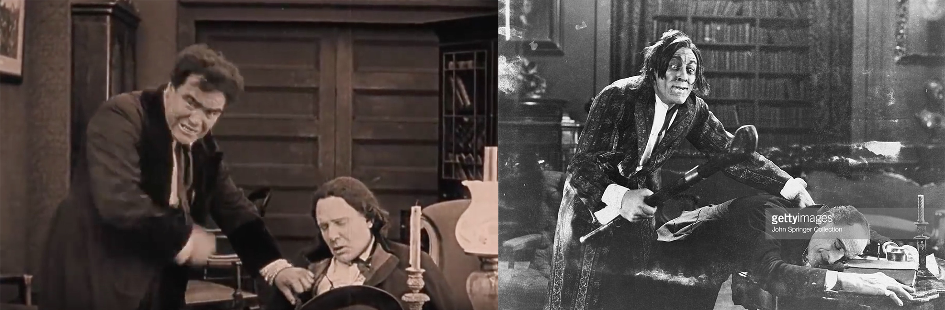
The probable intent to make Lynch appear as some sickly, malicious, nearly inhuman creature is even more visible in this still frame from a recent restoration of Griffith’s film. Note the splotchy makeup, and the facial expression which would later be famously sported by Universal Studios’ The Wolfman in 1941.
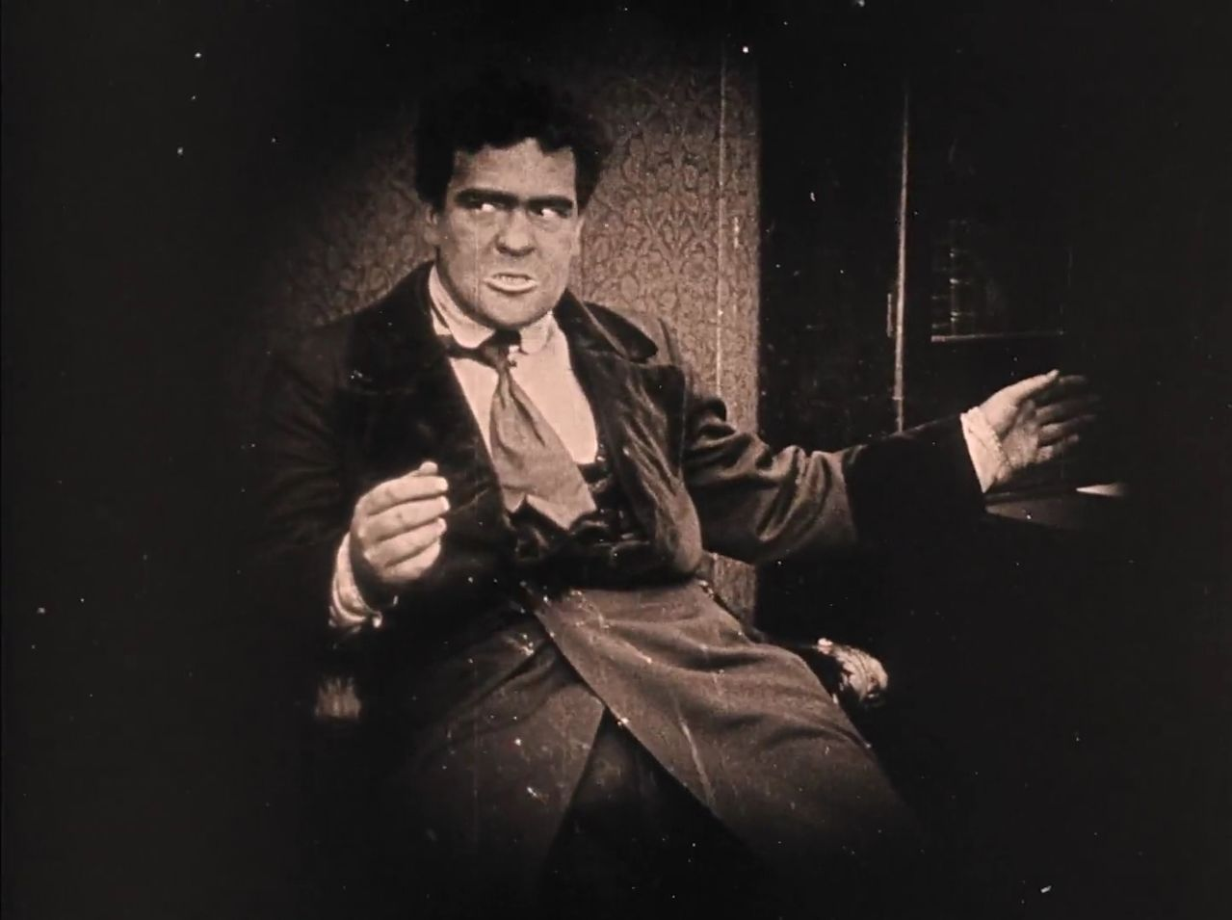

John Tyler Morgan and D.W. Griffith shared a number of claims between their respective arguments. Both also found success with persuading members of their audience through emotion-based appeals. But to a 1915 audience, I believe that Morgan’s essay would fall short due to its potential for confusion over what type of appeal is being made. Especially when compared to Griffith’s easy-to-follow narrative and strong visual elements, which were less reliant on the preconceptions of his audience. In addition, he was able to incorporate ideas from popular science of the time through a variety of cinematic techniques and visual characterizations, ultimately managing to show his audience even more than Morgan had told his.
Works Cited
Morgan, John Tyler. “The Race Question of the United States by John Tyler Morgan.” Plessy V. Ferguson A Brief History with Documents, New York:Banks & Brothers Law, 1996, pp. 68–74.
Gould, Stephen Jay. The Mismeasure of Man. W.W. Norton, 2008, pp. 60.

